**Phase-Aberrated Ultrasound Point Spread Function Estimation Using Convolutional Neural Network**

Wei-Hsiang Shen1 and Meng-Lin Li1, 2, 1Department of Electrical Engineering, National Tsing Hua University, Hsinchu, Taiwan, 2Institute of Photonics Technologies, National Tsing Hua University, Hsinchu, Taiwan.

**Background, Motivation and Objective**

*Point spread function (PSF) estimation is a fundamental problem in ultrasound imaging. The quality of the estimated PSF directly impacts all later processing such as deconvolution in ultrasound localization microscopy and phase aberration correction. Conventional methods often assume constant speed of sound in the imaging tissue but in reality, ultrasound imaging is body-dependent and sound-velocity inhomogeneous which creates phase-aberrated PSFs. In this work, we used deep learning techniques and trained a convolutional neural network that can estimate the phased-aberrated PSFs.*

**Statement of Contribution/Methods**

*We simulated radio frequency (RF) sound-velocity inhomogeneous ultrasound point spread functions (PSF) using the K-wave simulation toolbox by altering the phase-aberration profile of each channel. The phase-aberration profile followed the near field phase screen model which assume the profiles to have correlation length of 5 mm. Then, the PSFs were used to generate homogeneous speckle regions and together formed the training pairs. Afterwards, the training pairs were used to train a UNet-like convolution neural network that takes an RF ultrasound patch as input and predicts its corresponding PSF in a supervised setting. Since the network is trained using the mean square error loss function which calculates the pixel-wise difference, the PSFs need to be centered. We found that centering the center of mass of the PSF yields the best performance because phase-aberrated PSFs are often non-symmetric.*

**Results/Discussion**

*The neural network was tested using the validation split of the simulated pairs and showed promising results. In comparison with cepstrum-based approaches, the network could estimate the non-symmetric and out-of-focus PSFs. Note that in this work we assume the PSFs are spatially-invariant in the input RF patch and patch-wise estimation could be used to estimate the spatially-variant PSFs of the entire ultrasound image.*

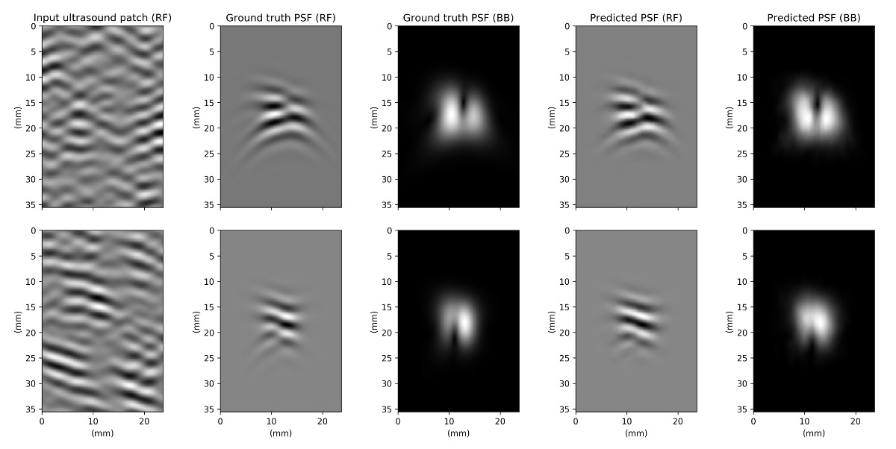

Fig 1. The neural network takes an ultrasound patch as input and predicts its corresponding radio frequency point spread function (RF PSF). Column 3 and 5 are the baseband-demodulated PSFs only for visualization purpose.